# Exercise: Computer Systems and Software - .NET 6.0

Problems for exercises and homework for the ["Software Technologies" course @ Software University.](https://softuni.bg/trainings/4086/software-technologies-may-2023)

## What is it and why do you need it?

**.NET** is a versatile, open-source development framework created by Microsoft that allows developers to build various types of applications, such as web, mobile, and desktop, using multiple programming languages like C# and F#. **QA engineers work with .NET** to test the functionality, performance, and compatibility of applications built on this platform, ensuring high-quality and reliable software across different environments and devices.

## How to install it?

**1.** First, you will need to navigate to [**https://dotnet.microsoft.com/en-us/download**](https://dotnet.microsoft.com/en-us/download)

For this tutorial, we are installing **.NET 6.0 Long Term Support, x64 version. Click on the button ".NET SDK x64**

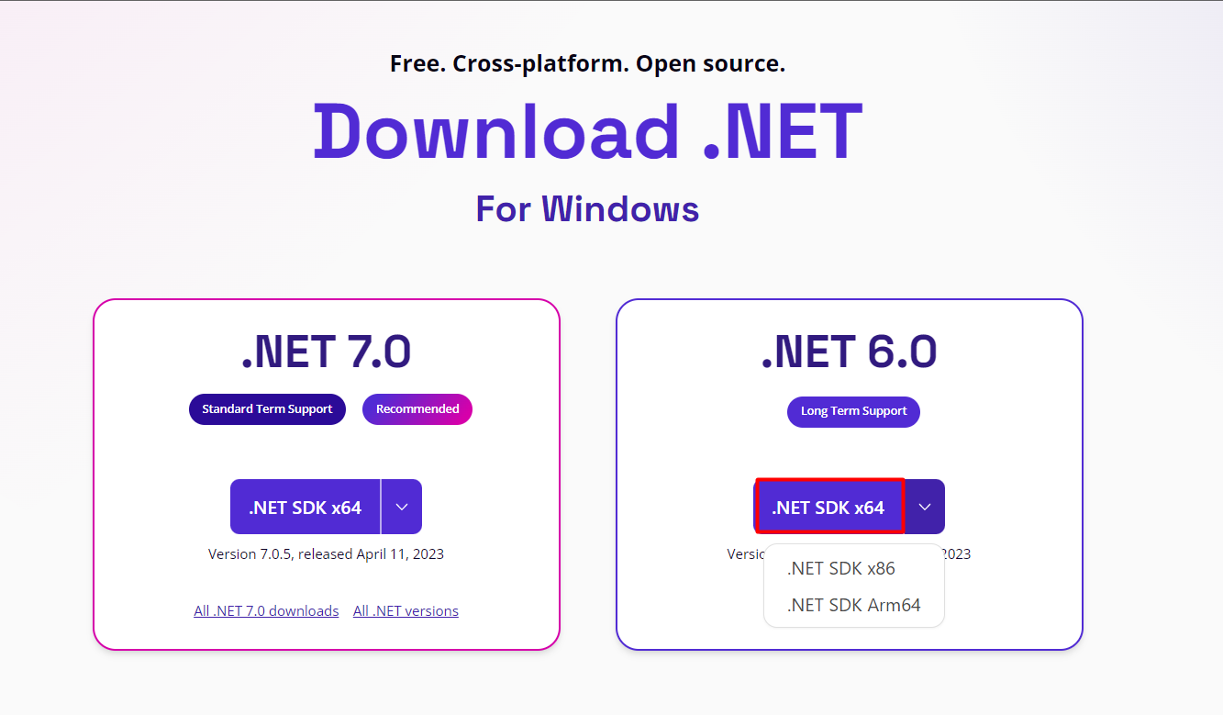

**2.** This will **download** the **installation file**.

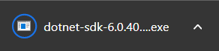

**3. Open** the .**exe file**. This will open the installer. Read the **Privacy Statement** and other provided information that might interest you and **hit Install**.

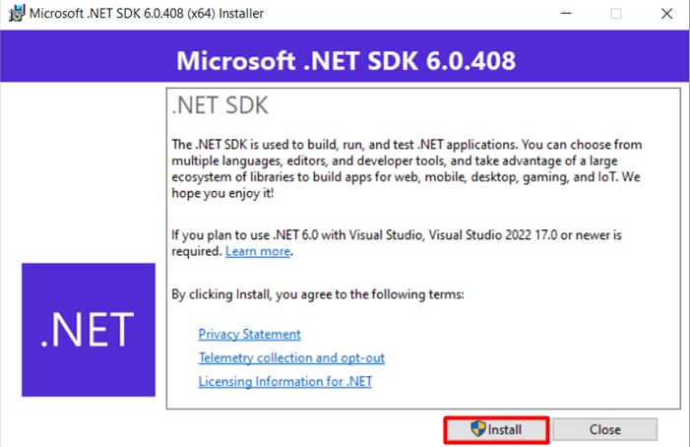

**4.** If prompted by Windows, **give permission to make changes** and your installation should begin.

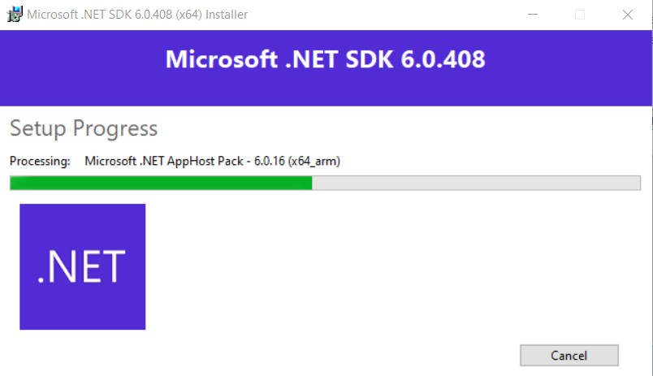

**5.** If the installation **is successful**, you will see the following window, which you should **now close.**

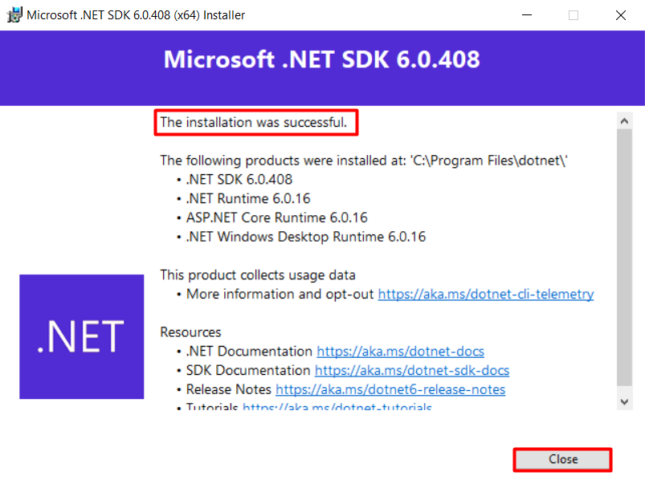

## Check .NET version

To check what was installed and its versions, type the following in the Command prompt:

**dotnet sdk check**

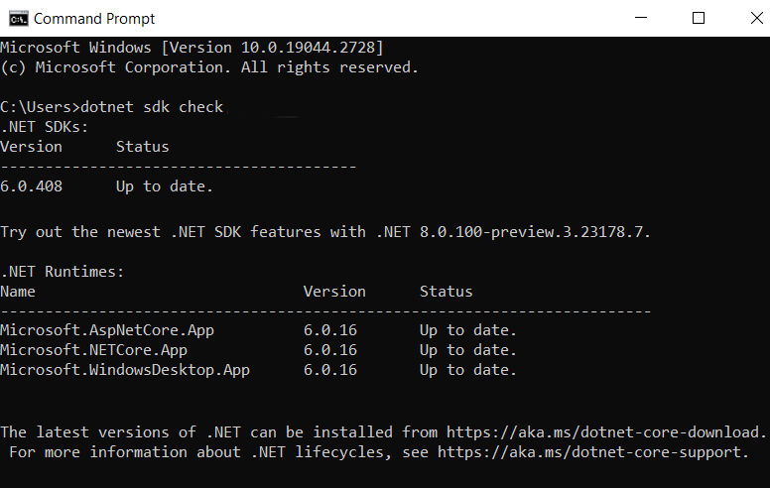

## Build and run a simple calculator

**We will build a simple calculator program, using .NET6.**

You are given a .zip archive named "SimpleCalc". Unzip it and place the folder on your desktop /or a place of your choosing, but keep in mind, that you will have to navigate to it via Command Prompt, so choose an easy for typing path/.

The folder contains two files: **Program.cs** and **SimpleCalc.csproj.** The first one is the code for our application and the second one is a C# project file that defines a project's settings, dependencies, and build configurations for a .NET application. If you are extremely curious, you can open those with Notepad or Notepad++ to see what's inside, but that is not necessary.

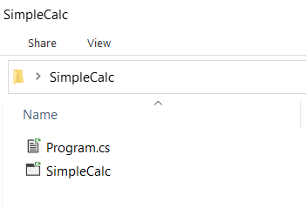

Open the Command Prompt (by default Command Prompt opens in C:\Users\YourUsername) and navigate to the "SimpleCalc" folder. Here we are assuming that the folder is placed on your desktop. Type the following command:

**cd desktop\simplecalc**

Now we will build our calculator by running the following command:

**dotnet build**

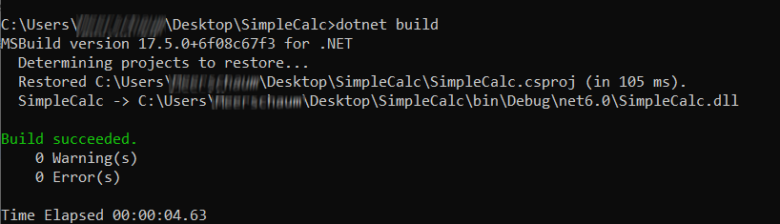

Next, we will run the calculator by typing the following command:

**dotnet run**

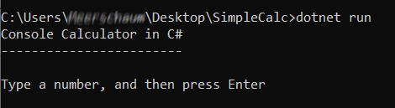

You can see our **simple calculator in action**.

Type a number. Type a second number. Choose an arithmetic action. Get a result.

